Name:P.Gayathri
Reg.No:192424324

6.Write a Python program to simulate the Vacuum Cleaner Problem in Artificial Intelligence.

Aim:
To implement a Python program that simulates the working of a vacuum cleaner agent to clean all dirty rooms.
Algorithm:
Step 1: Start.
Step 2: Read the status of Room A and Room B (Clean/Dirty).
Step 3: Place the vacuum cleaner in Room A.
Step 4: Check the status of the current room.
Step 5: If the room is dirty, clean it.
Step 6: Move the vacuum cleaner to the next room.
Step 7: Repeat Steps 4–6 until all rooms are checked.
Step 8: Display the final status of both rooms.
Step 9: Stop.

PROGRAM:
rooms = {
"A": input("Enter status of Room A (Clean/Dirty): "),
"B": input("Enter status of Room B (Clean/Dirty): ")
}

for room in rooms:
print("Vacuum is in Room", room)
if rooms[room].lower() == "dirty":
print("Cleaning Room", room)
rooms[room] = "Clean"
else:
print("Room", room, "is already Clean")

print("\nFinal Room Status:")
for room in rooms:
print("Room", room, ":", rooms[room])

INPUT:
Enter status of Room A (Clean/Dirty): Dirty
Enter status of Room B (Clean/Dirty): Clean

OUTPUT:
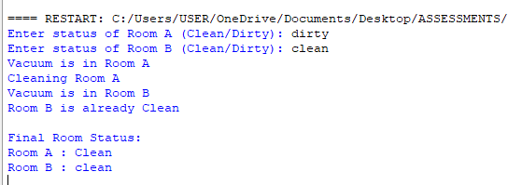

RESULT:
Thus, the Python program to simulate the Vacuum Cleaner Problem was implemented successfully, and all dirty rooms were cleaned.

